Amazon SQS (Simple Queue Service)
Amazon SQS (Simple Queue Service) is a fully managed message queuing service provided by AWS. It allows different applications, services, or microservices to communicate asynchronously by sending and receiving messages through a queue.

Real-Time Example
Imagine an online shopping application like Amazon.
- Customer places an order.
- The website immediately confirms the order.
- Payment service processes payment.
- Inventory service updates stock.
- Shipping service prepares delivery.
- Notification service sends email/SMS.
Without SQS:
- Every service depends on every other service.
- If the payment server is slow, the website becomes slow.
- If shipping service crashes, the whole application may stop.
With SQS:
- Website places the order into an SQS queue.
- Other services read the messages whenever they are ready.
- Even if one service is down, the message safely remains in the queue.
This makes applications reliable, scalable, and fault tolerant.

Types of Queues
There are only two queue types.

Standard Queue
Most commonly used.
Features
- Unlimited throughput
- At least once delivery
- Best effort ordering
Example
Restaurant Orders
Order1

Order3

Order2
Order may change.

FIFO Queue
FIFO = First In First Out
Order1

Order2

Order3
Always same order.
Exactly once processing.

Task 1: Create and Configure AWS Simple Queue Service (SQS)

Objective
Learn how to:
- Create an SQS Queue
- Send messages
- Receive messages
- Delete messages
- Configure Visibility Timeout
- Configure Dead Letter Queue (DLQ)

Architecture
Application A (Producer)
│
│ Send Message
▼
+----------------------+
| SQS Queue |
+----------------------+
│
│ Receive Message
▼
Application B (Consumer)

Prerequisites
- AWS Account
- IAM User with SQS Full Access
- Region: us-east-1 (recommended)

Step 1: Open SQS
- Login to AWS Console
- Search
SQS
- Open SQS Dashboard.

Step 2: Create Queue
Click
Create Queue
Select
Standard Queue
Queue Name
OrderQueue
Leave everything default.
Click
Create Queue
Queue created successfully.
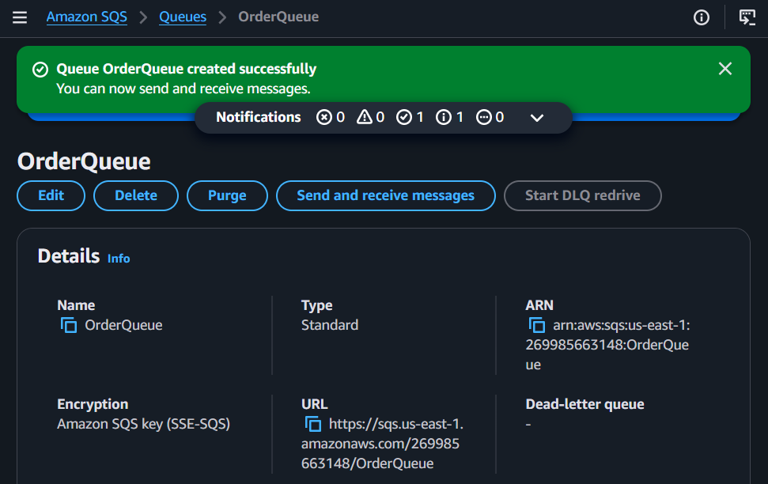

Step 3: View Queue Details
Open
OrderQueue
Observe
- Queue URL
- ARN
- Message Retention
- Visibility Timeout
- Delay Queue
Write these values in your document.
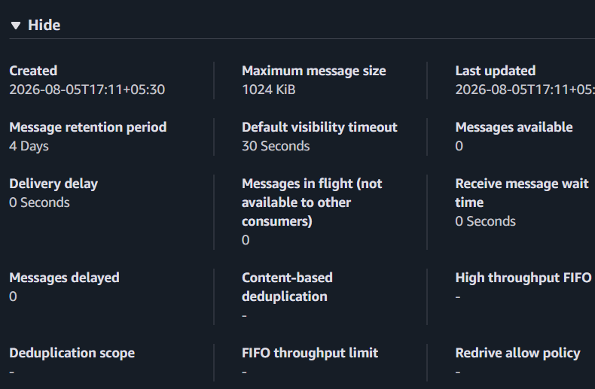

Step 4: Send Message
Click
Send and receive messages
Message Body
Customer ordered iPhone 16
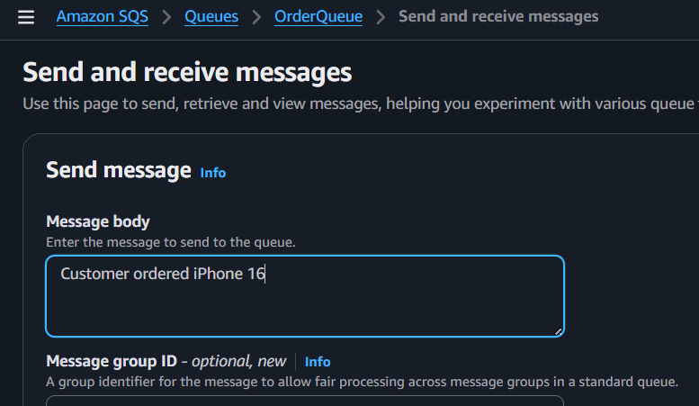
Click
Send Message
Repeat
Customer ordered Laptop

Customer ordered TV

Customer ordered Shoes
Now
Approximate Number of Messages = 4

Step 5: Receive Messages
Click
Poll for Messages
You'll see
Customer ordered iPhone 16

Customer ordered Laptop

Customer ordered TV

Customer ordered Shoes
Observation
Messages become invisible temporarily.
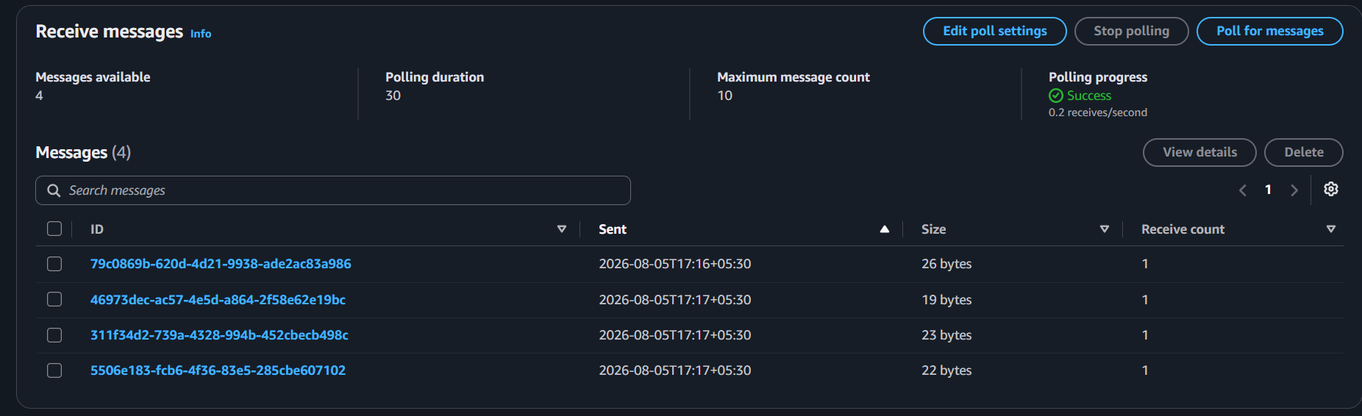

Step 6: Delete Message
Select
Delete
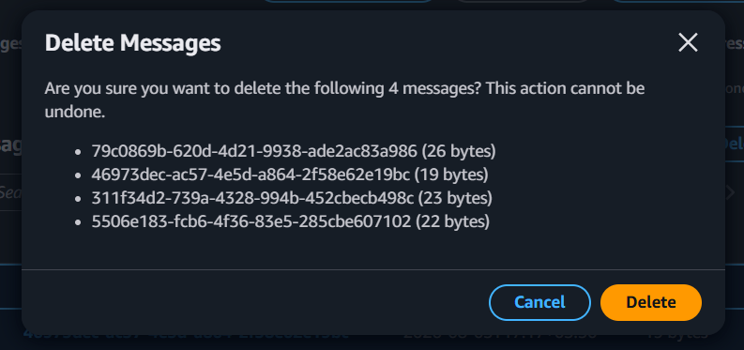
Delete all messages.
Queue becomes empty.
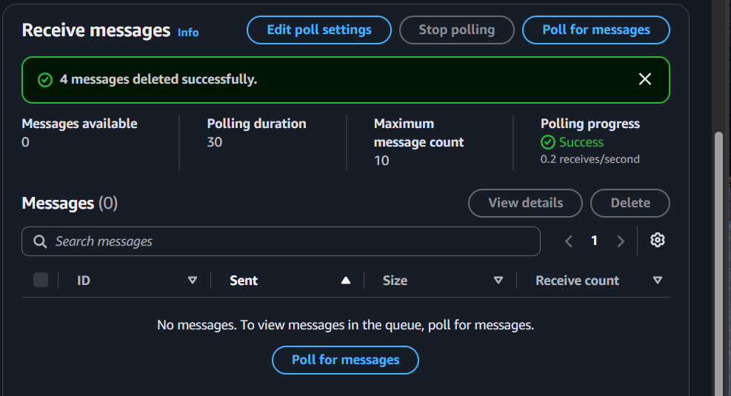

Step 7: Test Visibility Timeout
Open Queue
Choose
Edit
Visibility Timeout
Change
30 seconds

↓

60 seconds
Save.
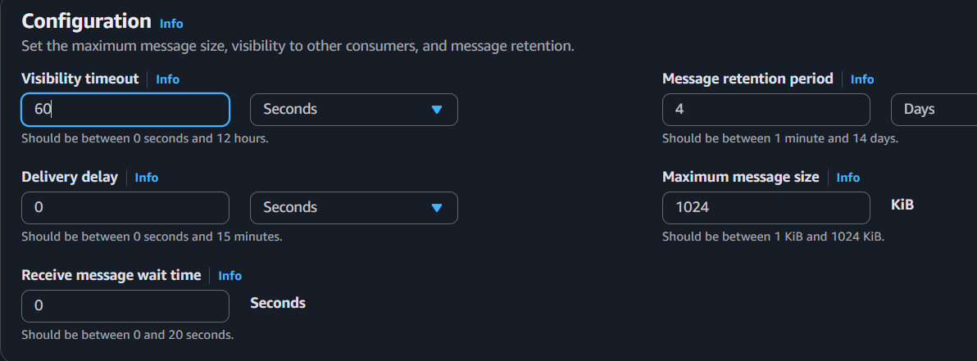
Send a message
Test Visibility
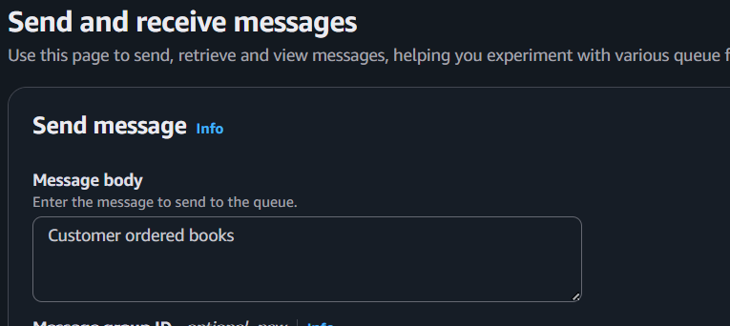
Receive the message.
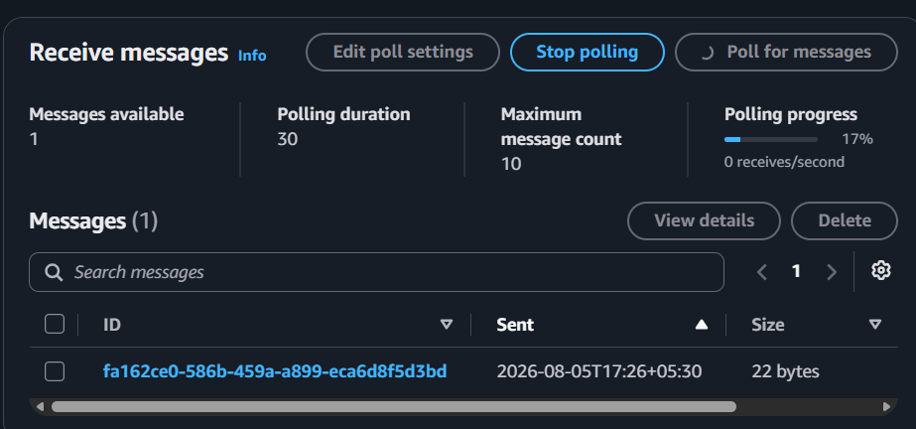
Don't delete it.
Wait.
Observe
The message disappears.
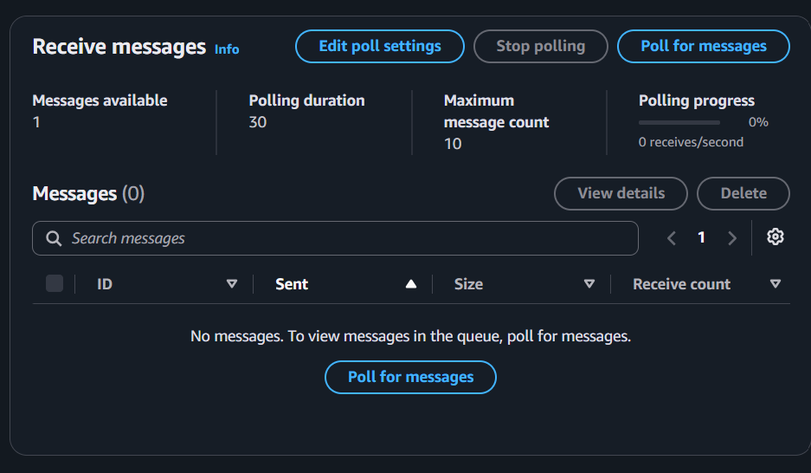
After
60 seconds
It appears again.
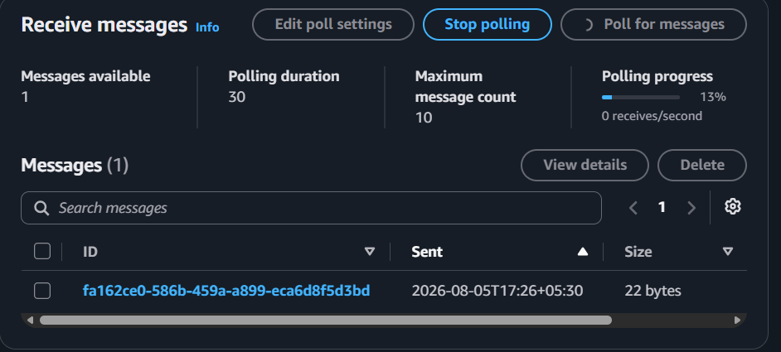
Observation
Visibility Timeout prevents multiple consumers from processing the same message simultaneously.

Step 8: Configure Delay Queue
Open Queue
Edit
Delay Queue
30 seconds
Save.
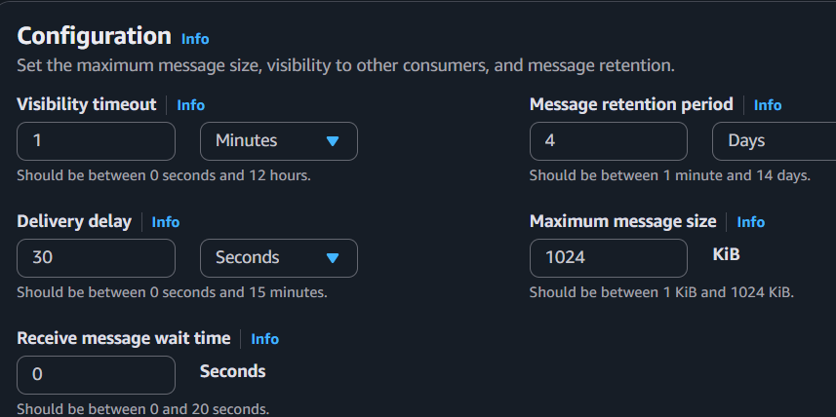
Send message
Delayed Order
Immediately poll.
No message.
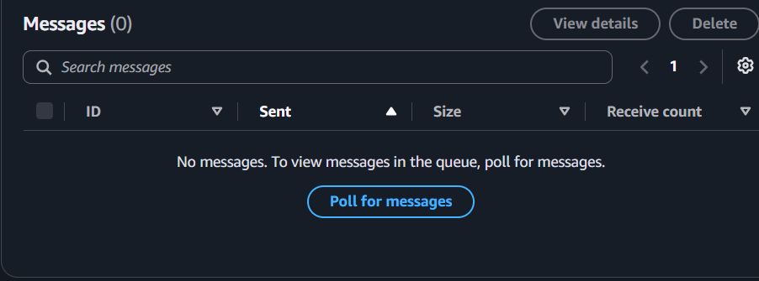
Wait
30 seconds
Poll again.
Message appears.
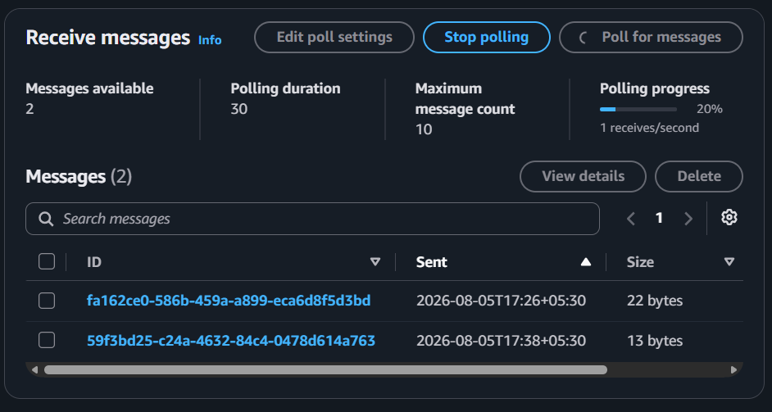

Step 9: Create Dead Letter Queue
Create another queue
Name
OrderDLQ
Type
Standard
Create.
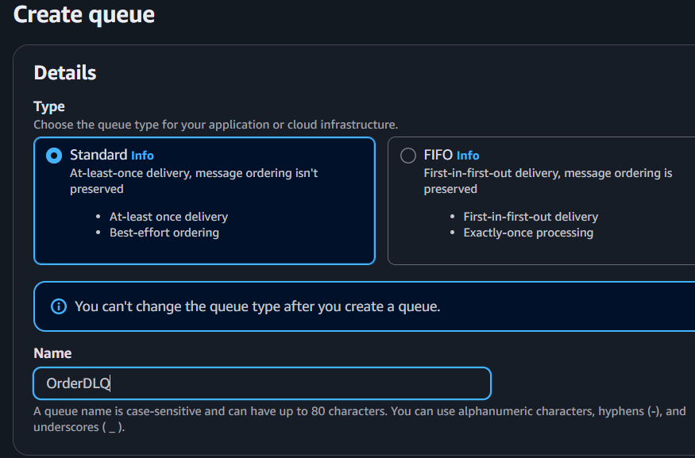
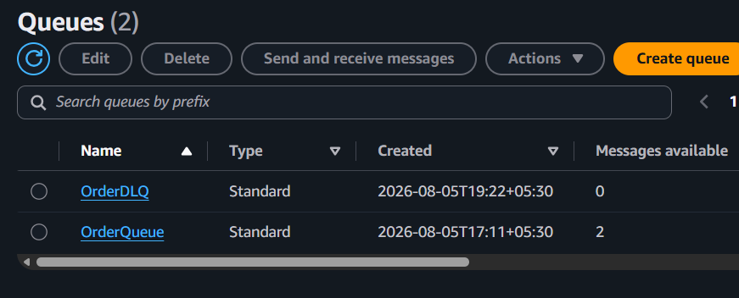

Step 10: Attach DLQ
Open
OrderQueue
Edit
Dead-letter Queue
Choose
Enabled
Select
OrderDLQ
Maximum Receives
3
Save.
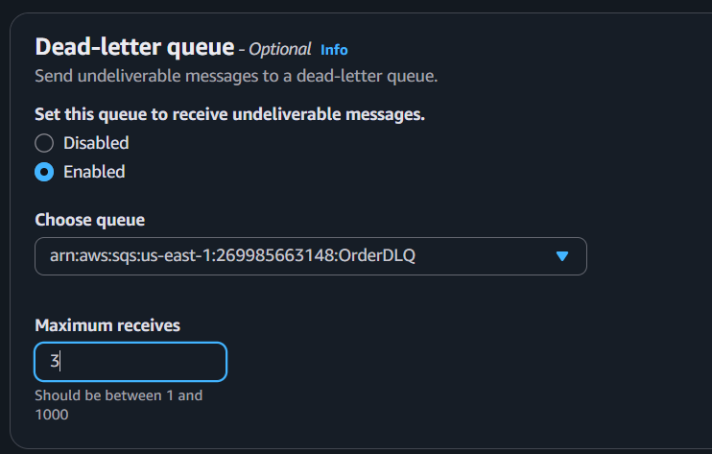

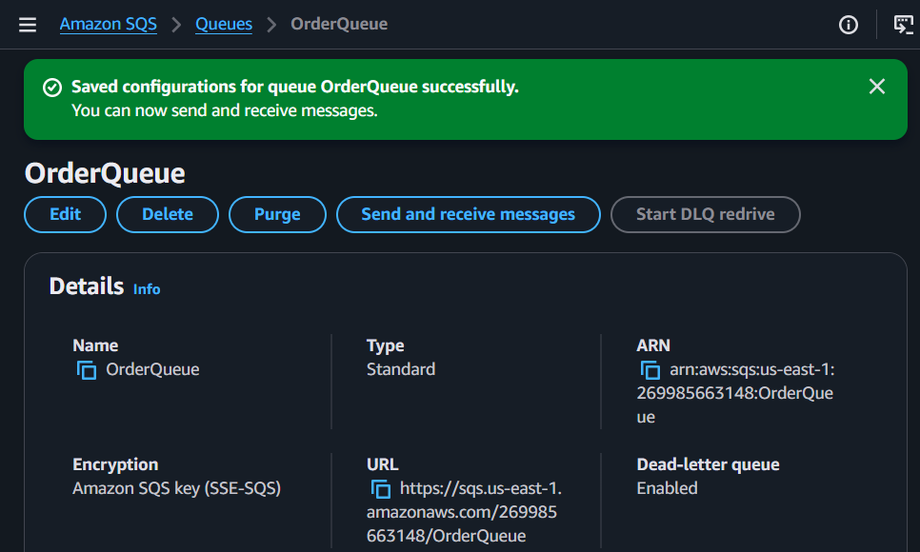

Step 11: Test DLQ
Send message
Invalid Order
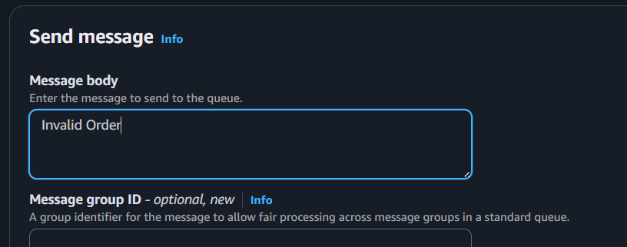
Receive it.
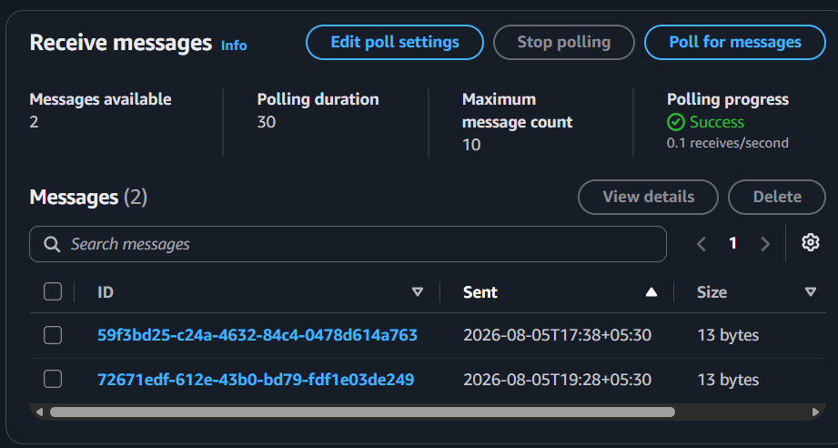
Don't delete it.
Wait until visibility timeout expires.
Receive again.
Repeat
3 times
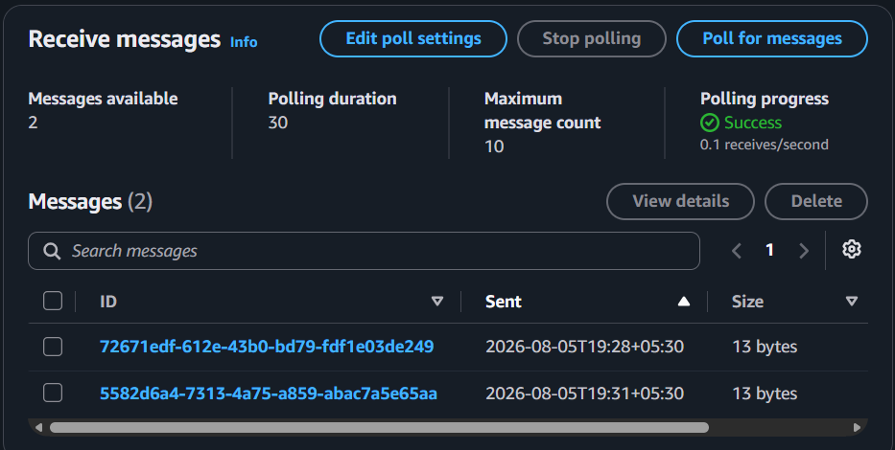

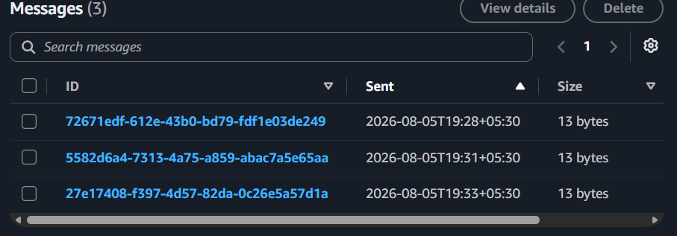
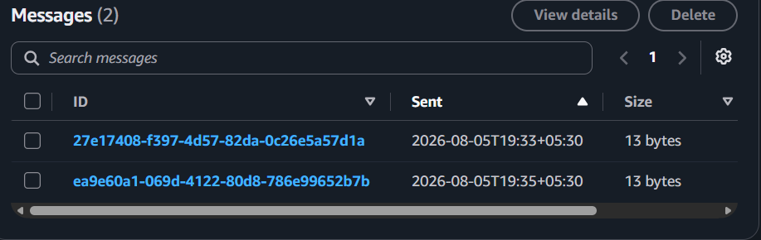

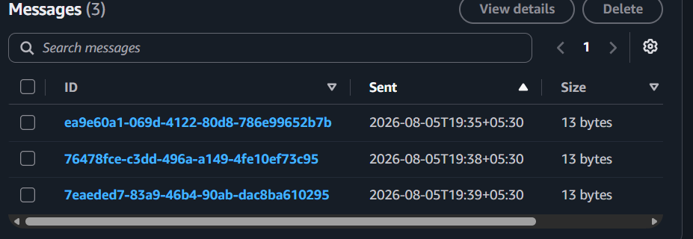
After the maximum receive count, check the OrderDLQ. The message should move there automatically.
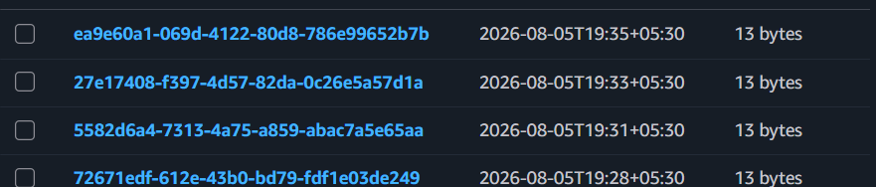

Step 12: Monitor Queue
Observe
- Available Messages
- In Flight Messages
- Empty Receives
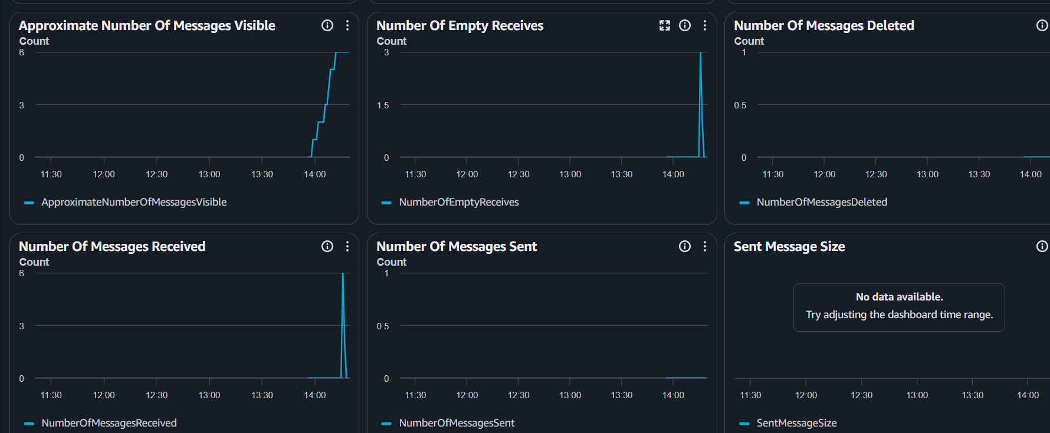
CloudWatch metrics are created automatically.
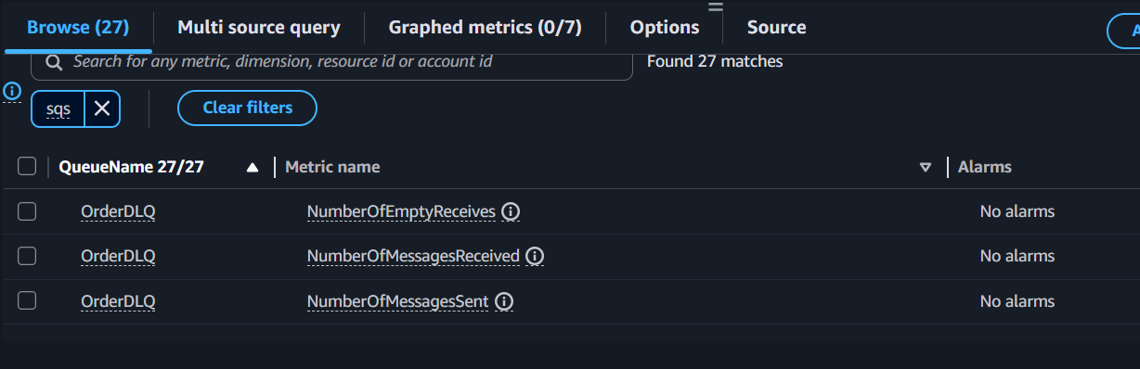

Observations for SQS
- Messages are stored reliably.
- Multiple producers can send messages.
- Consumers process messages independently.
- Visibility Timeout prevents duplicate processing.
- Delay Queue postpones message delivery.
- Dead Letter Queue isolates failed messages.
- CloudWatch provides queue metrics.

Implementation Document (SQS)

Architecture
Producer → SQS Queue → Consumer

Configuration Steps
- Created Standard Queue
- Sent messages
- Received messages
- Deleted messages
- Configured Visibility Timeout
- Configured Delay Queue
- Configured DLQ
- Tested DLQ
- Verified CloudWatch metrics

Result
Successfully implemented and tested all core SQS features.

